K. J. Somaiya College of Engineering, Mumbai-77(A Constituent College of Somaiya Vidyavihar University)Department of Mechanical Engineering
Performance Analysis of Parabolic Trough Collector
Mini Project Report
Presented by: Awwab Khot-16010520091 Manan Gandhi- 16010520091 Amod Zack-16010520102
Guided by: Prof. Shailesh Nikam

Introduction
Parabolic trough collectors are formed by a cylindrical surface of mirrors with a parabolic shape that concentrates solar radiation on a receiver tube located at the focal point of the parabola. A fluid, normally synthetic oil, circulates inside the receiver tubes and is heated up by the sun (around 400 ºC). The fluid is then pumped through heat exchangers to generate steam which is thus used to produce electricity in a conventional turbine.

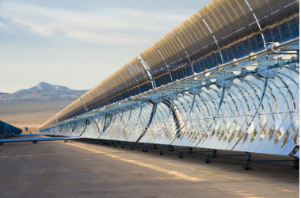

Purpose
Solar radiation reaches the Earth's upper atmosphere with the
power of 1366 watts per square meter (W/m2). Many technologies
have been developed to make use of solar radiation. Some of these
technologies make direct use of the solar energy (e.g. to provide
light, heat, etc.), which helps us to generate electricity.

The trough is fabricated with FRP (Fibre Reinforced Plastic) plate
in parabolic shape, FRP material is preferred to withstand wind
force and also extended life of setup. The setup is mounted on a
stand which is fabricated with mild steel angles.

We are going to evaluate the performance of the PTC by using
different fluids and for further research using the power generated
for human purpose.

Principle
A parabolic trough solar collector (PTC) takes the radiant energy from the sun and converts it to useful thermal energy in the heat transfer fluid (HTF) that circulates through the solar field.

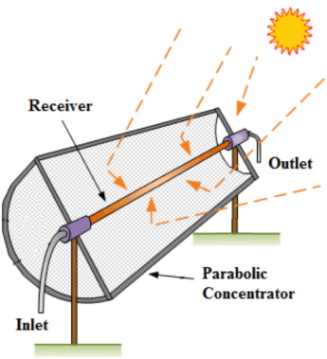

Methodology
A parabolic trough solar air heater incorporated with an evacuated tube inserted with a double pipe heat exchanger

The experimental setup is shown below. The reflector is made of a stainless-steel.

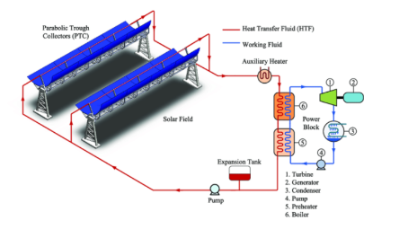

Components involved
The main component of the experimental setup and the constructional detail of the setup are described below:
- Parabolic Trough:
A parabolic trough is a type of solar thermal collector that is straight in one dimension and curved as a parabola in the other two, lined with a polished metal mirror. The sunlight which enters the mirror parallel to its plane of symmetry is focused along the focal line, where objects are positioned that are intended to be heated.

- Copper Tubes:
Copper tubing is most often used for heating systems and as a refrigerant line in HVAC systems.

- Focusing Mirror:
Focusing mirrors are mirrors cut from a parabola of reflecting material; the parabola is fabricated in such a way that distant rays will be bent through a single point i.e. the focus of the mirror.

- Thermocouple:
A thermocouple is a sensor that measures temperature. It consists of two different types of metals, joined together at one end. When the junction of the two metals is heated or cooled, a voltage is created that can be correlated back to the temperature.

- Rotameter:
A rotameter is a flow meter device that measures the volumetric flow rate of a gas or fluid. It consists of a tapered tube with a moving internal float. It is sometimes referred as mechanical flow meters, gravity flow meters or variable area flow meters.

Fluids
- Water
- Mono-ethylene Glycol
- Theminol-55

Analysis Using Software
The System Advisor Model (SAM) is a free techno-economic software model that facilitates decision-making for people in the renewable energy industry:
- Project managers and engineers
- Policy analysts
- Technology developers
- Researchers
SAM can model many types of renewable energy systems:
- Photovoltaic systems, from small residential rooftop to large utility-scale systems
- Battery storage with Lithium ion, lead acid, or flow batteries for front-of-meter or behind-the-meter applications
- Concentrating Solar Power systems for electric power generation, including parabolic trough, power tower, and linear Fresnel
- Industrial process heat from parabolic trough and linear Fresnel systems
- Wind power, from individual turbines to large wind farms
- Marine energy wave and tidal systems
- Solar water heating
- Fuel cells
- Geothermal power generation
- Biomass combustion for power generation
- High concentration photovoltaic systems
This software can be used as a calculator in such a way that we input values and obtain results as per our requirement. We have used this software for the project in order to input parameters related those fluids which are not available with us physically.

Calculations

Results

